**Name:- Samarth H Bhavsar**

**ASSINGMENT : NETWORK FUNDAMENTALS**

**1. Which of the following messages in the DHCP process are broadcasted? (Choose two)**  A. Request

1. Offer
2. Discover
3. Acknowledge

**Ans:-**

**A. Request**  **C. Discover**

**Explanation:-** In the DHCP process, the "Discover" message is broadcasted by the client to find available DHCP servers. The "Request" message is also broadcasted by the client to request the offered IP address from the server. The "Offer" and "Acknowledge" messages are unicast from the server to the client.

**2. Which command would you use to ensure that an ACL does not block web-based TCP traffic?**

1. permit any
2. permit tcp any any eq 80

C permit tcp any eq 80

D. permit any any eq tcp

**Ans:-** **B.** permit tcp any any eq 80

**Explanation:-** The command "permit tcp any any eq 80" allows TCP traffic on port 80, which is the default port for HTTP web traffic. This ensures that web-based traffic is not blocked by the ACL. The other options either don't specify the correct port or use incorrect syntax.

**3. Explain Network Topologies**

**Ans:-**

Network topologies refer to the layout or arrangement of different elements (links, nodes, etc.) in a computer network. The most common types are:

* **Bus Topology:-** All devices are connected to a single central cable (the bus). It's simple but if the main cable fails, the entire network goes down.
* **Example:-**

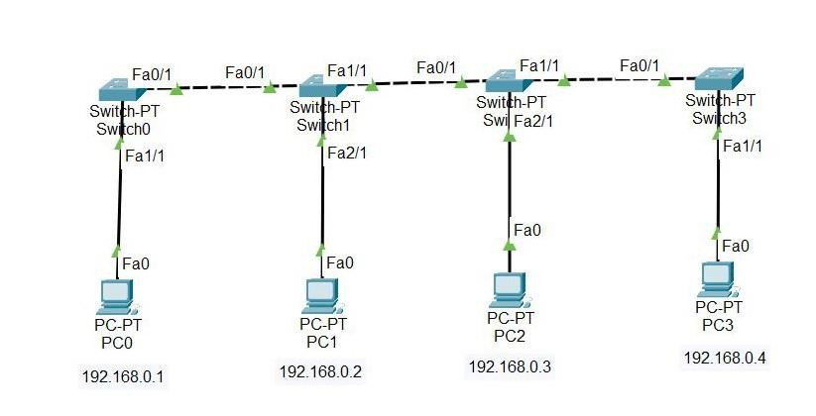

* **Star Topology:-** All devices are connected to a central hub or switch. It's easy to manage and troubleshoot, but if the central hub fails, the network is affected.
* **Example:-**

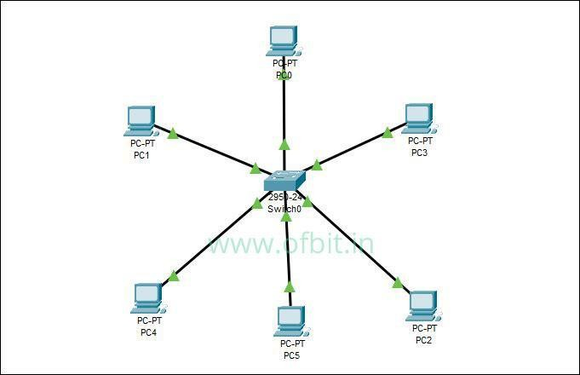

* **Ring Topology:-** Devices are connected in a circular manner, where each device has exactly two neighbors. Data travels in one direction (or two in a dual ring), but if one device fails, the entire network can be impacted.

**-**

**Example:**

**-**

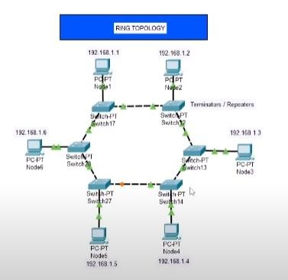

* **Mesh Topology:-**  Every device is connected to every other device. It offers high redundancy and reliability but is expensive and complex to implement.
* **Example:-**

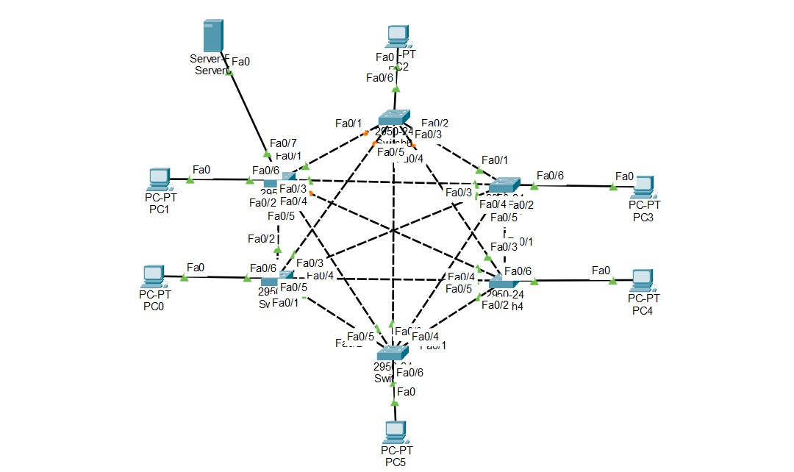

* **Hybrid Topology:-** A combination of two or more different types of topologies, making it flexible and scalable.

**-**

**Example:**

**-**

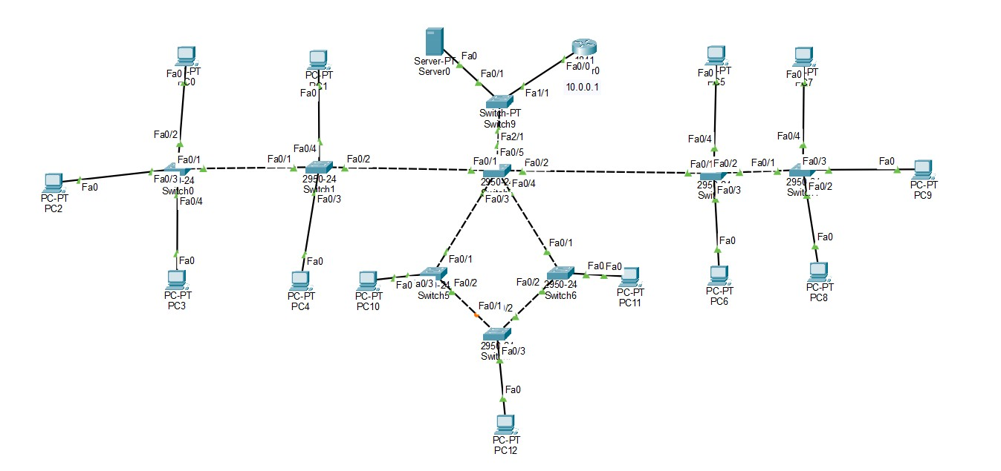

**Explanation:-** Understanding network topologies helps in planning and designing a network that meets specific needs, balancing factors like cost, reliability, and ease of management.

**4. Explain TCP/IP Networking Model**

**Ans:-**

The TCP/IP model is a set of protocols used to enable communication over the internet. It consists of four layers:

* **Application Layer:-** This layer interacts with software applications and provides protocols like HTTP, FTP, SMTP, etc., for different types of data communication.

* **Transport Layer:-** Ensures reliable data transfer between devices using protocols like TCP **(connection-oriented)** and UDP **(connectionless)**.

* **Internet Layer:-**  Manages logical addressing and routing using protocols like IP (Internet Protocol), which defines how packets are sent from source to destination.

* **Network Access Layer:-** Deals with the physical transmission of data over network media, including hardware devices and the link-layer protocols (e.g., Ethernet).

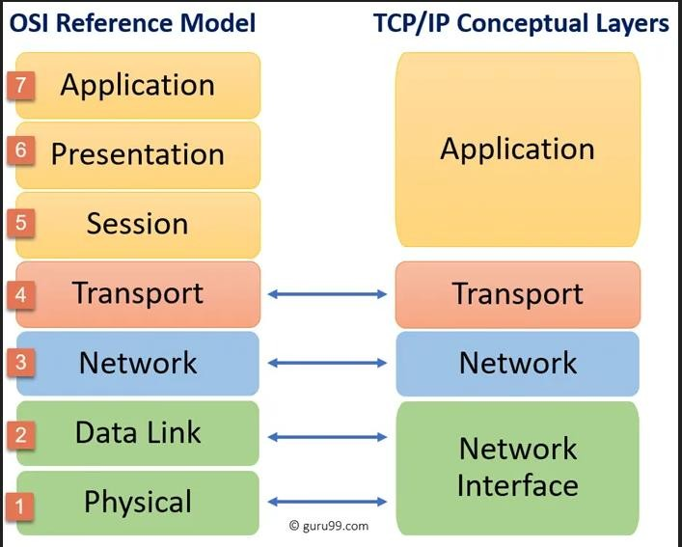

**Explanation:-**  The TCP/IP model is the foundation of the internet and most modern networks, providing a standardized way for devices to communicate and exchange data across diverse networks.

**5. Explain LAN and WAN Network**

**Ans:-**

* **LAN (Local Area Network):-** A LAN is a network that covers a small geographical area, such as a home, office, or campus. LANs are used to connect computers and devices within a close proximity to share resources like files, printers, and internet connections. They usually offer high-speed data transfer rates and are managed by a single organization.

* **WAN (Wide Area Network):-** A WAN covers a broad geographical area, often connecting multiple LANs across cities, regions, or even countries. WANs use long-distance transmission technologies like leased lines, satellite links, or VPNs to connect remote networks. They are typically slower than LANs due to the distance covered and are often managed by multiple organizations or service providers.

**Explanation:-** LANs are ideal for small-scale networks within a building or campus, while WANs are essential for connecting remote locations, enabling communication and resource sharing across vast distances.

**6. Explain Operation of Switch**

**Ans:-**

A switch is a network device that operates at the Data Link layer (Layer 2) of the OSI model. It is used to connect multiple devices within the same network (typically within a LAN) and intelligently forward data packets to the correct destination based on MAC addresses. Here’s how it works:

* **MAC Address Learning:-** The switch learns the MAC addresses of connected devices by examining the source MAC address of incoming frames.

* **Forwarding/Filtering:-** When a frame arrives, the switch looks up the destination MAC address in its MAC address table. If the address is found, the switch forwards the frame to the appropriate port. If not, it broadcasts the frame to all ports (except the one it came from).

* **Loop Prevention:-** Switches use protocols like Spanning Tree Protocol (STP) to prevent loops in the network, which can cause broadcast storms and network failures.

**Explanation:-** Switches are fundamental to modern LANs, providing efficient and scalable connections between devices by ensuring data is only sent where it’s needed, improving overall network performance.

**7. Describe the purpose and functions of various network devices Ans:-**

* **Router:-** Connects multiple networks and directs data between them, using IP addresses to determine the best path for data packets.

* **Switch:-** Connects devices within a single network, using MAC addresses to forward data to the correct device.

* **Firewall:-** Monitors and controls incoming and outgoing network traffic based on security rules, protecting the network from unauthorized access.

* **Access Point (AP):-** Allows wireless devices to connect to a wired network using Wi-Fi, often used to extend the reach of a wireless network.

* **Modem:-** Converts digital data from a computer into a format suitable for a telephone or cable line and vice versa, enabling internet access.

* **Repeater:-** Amplifies or regenerates signals to extend the distance over which data can travel without degradation.

**Explanation:-** Each network device has a specific role, contributing to the overall functionality, security, and efficiency of the network. Understanding their purposes helps in designing a well-functioning network.

**8. Make a list of the appropriate media, cables, ports, and connectors to connect switches to other devices**

**Ans:-**

* **Media:-**
* Twisted Pair Cable (e.g., Cat5e, Cat6)
* Fiber Optic Cable (e.g., Single-mode, Multi-mode)

* **Cables:-**
* Ethernet Cable (e.g., Cat5e, Cat6, Cat6a)
* Fiber Optic Cable

* **Ports:-**
* RJ45 Port (for Ethernet cables)
* SFP Port (for fiber optic cables)

* **Connectors:-**
* RJ45 Connector (for Ethernet cables)
* LC or SC Connector (for fiber optic cables)

**Explanation:-**  Using the correct media, cables, ports, and connectors is crucial for ensuring reliable and high-speed connections between switches and other network devices. The choice depends on the network’s requirements and the distance between devices.

**9. Define Network devices and hosts**  **Ans:-**

* **Network Devices:-**  These are hardware components used to build and manage networks. Examples include routers, switches, firewalls, modems, and access points. These devices facilitate communication, control data flow, enhance security, and extend network coverage.

* **Hosts:-**  A host is any device that has an IP address and can send or receive data over the network. Examples include computers, servers, printers, smartphones, and other internetconnected devices. Hosts are the end devices in a network that generate, receive, or store data.

**Explanation:-**  Network devices are the building blocks that create the network infrastructure, while hosts are the end-user devices that use the network to communicate, access services, and perform tasks. Both are essential for a functioning network.